# PROFILE

**Pesaro 07.10.1987**

**Italian**

**+39 3494454840 tgiulia7@gmai.com**

**Pappelstrasse 49, 4123 Allschwil, Basel**

**Italian, English, German, French**

# AWARDS

**2017** FAUST price for “Fall 7 Times” of Guy Nader & Maria Campos co creation with Tanzmainz dancers

**2011** scholarship awarded for studies at Peridance Capezio school in New York Union Square

**2009** tour in Macedonia for Codarts with creation “Nosy” of *Georg Reischl*

# EDUCATION

**2024** Dance Well program in Bassano del Grappa

**2023** Level 1 Certification of Gyrotonic

**2011** dance video “The Cage” from *Mauro Astolfi* in collaboration with DAF and ***Spellbound***

**2009/2010** internship with ***Ballet van Leth*** for festival Parade in different cities in Holland and in Spui Theatre

**2006-2010** Bachelor degree in Rotterdam Dance Academy/***CODARTS***.

**2008/2009** Performance projects of visual arts with stylist

Helen Grass, and Video Makers Academy

**2007/2008** Project through Rotterdam Dance Academy

with ***Cirque du Soleil*** for “Varekai”

**2003-2006** Performed with a young group of actors of high schools

**2001-2006** High school with diploma in

Lyceum Socio-Psico-Pedagogico

**1996-2000** Several experiences in different

sports, especially in synchronized swimming

**1990-2006** “Centro Studi Danza” of *Paola*

*Forlani*, private school, ballet R.A.D. technique

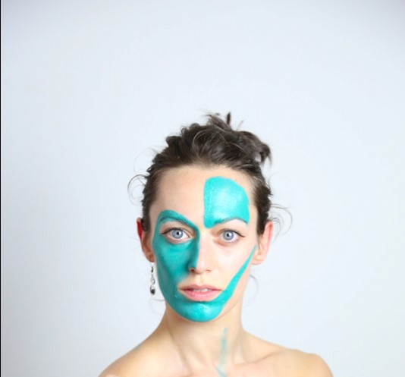

# GIULIA TORRI

## PROJECTS / Work Experiences

**2024/2025 *Ballet Basel different*** direction Adolphe Binder and Tilman O’ Donnell Choreographers from Iceland (Erna Omarsdóttir and Halla Ólafsdóttir) and makers from the UK (Tim Etchells and Vlatka Horvat).

**2024** solo “This is Giulia” by and with *Masako Matzushita*

**2023** site-specificimprovisation performances collaborating with *Elisabetta Consonni* and *Masako Matzushita*.

**2021/2022** “Rinascita” - a gallery performance with multidisciplinary artists, maker and performer. “Giaro in luce”, coproduced by ***Hangartfest,*** developed and performedby native Pesaro artists *Masako Matsushita, Matteo Marfoglia, Elda Gallo, Luca Signoretti* and *Melissa*



*Ugolini*, event dedicated to the Pesaro composer Paolo Giaro

**2019/2020** two different residency projects with *Masako Matzushita,* and also work with “Collective A Priori”

**2017/2018 *Teatro Regio di Torino*** in the Opera “Turandot” directed by *Stefano Poda*

**2014-2017 *Staatstheather Mainz, Tanzmainz*** original creations with choreographers: *Jo Stromgren, Sharon Eyal, Giuseppe Spota, Jose Navas, Club Guy & Rony, Garry Stewart,*

*Guy Nader & Maria Campos, Koen Augustijnen* & *Rosalba*

*Torres Guerrero*

Assisting Felix Berner with Jugendclub, tanzmainz, performances in Berliner Festspiele

**2013/2014 *Delattre Dance Company***in Mainz *(Regina van Berkel, Ralitza Malehounova)*

**2012** Italian tour with ***Astra Roma Ballet***with “Eleonora Duse” from *Sabrina Massignani*

**2010** project with Italian group of students of Rotterdam Dance Academy, our own dance event, “Anime salve in terra e in mare”; a tribute to Fabrizio De Andrè performed around

The Netherlands and Italy